Chapter 7 Body coordination

extra worksheet 1: Endocrine system

Hormones are chemical substances that act as messengers in the body. They are produced in endocrine glands scattered throughout the body. Together, all these glands form the endocrine system.
A part of the brain called the hypothalamus constantly checks the internal environment of the body and, if these conditions change, the hypothalamus sends signals to the nearby pituitary gland. The pituitary gland responds to these signals by either secreting hormones or releasing less of a particular hormone. The hormones from the pituitary gland control the activities of other endocrine glands such as the thyroid, parathyroid, thymus, adrenal glands, pancreas, ovaries and testes. The endocrine system controls important aspects of the body such as body temperature, rate of metabolism and water content.
Although hormones reach all your body cells they do not affect all the cells. Hormones are specific and act only on their target cells.

Questions
1 Name the parts of the endocrine system labelled A to G in Figure 1.
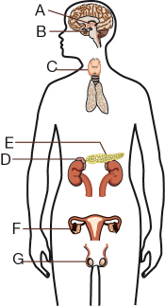
Figure 1 Endocrine system.

2 Use the following terms to complete the sentences below.
receptors blood stream target cells endocrine glands hormones
The chemical messengers of the endocrine system are known as __________________. They are produced in _____________________. Hormones move in the _______________ to reach every cell in the body. However, not every cell responds to the message. Only cells with specific ________________ react. They are ________________.

3 Compare the nervous and endocrine systems by completing the table.

Nervous system | Endocrine system
Messages travel along  ________________________ | Messages travel in the  ________________________
Messages are in the form of  ________________________ | Messages are in the form of  ________________________
Messages travel in ______________ direction. | Messages travel throughout the body but only act on _____________
Messages cause very ___________ reactions. | Messages cause _________ changes.
Controls things like:  ____________________________  ____________________________ | Controls things like:  ____________________________  ____________________________

